

Programme Name: ________**BCS HONS**_______________________________________

Course Code: __**CSC 1000**________

Course Name: ________**Introduction to Statistics**______________________________

_**Internal Examination**___

Date of Submission: ______**4/29/2021**_____________

**Submitted By: Submitted To:**

Student Name**: CSC_1000_Dipesh Tha Shrestha** Faculty Name**: Shanta Rayamajhi Basnet**

IUKL ID: **041902900028** Department**: LMS**

Semester**: Third Semester**

Intake**: September 2019**

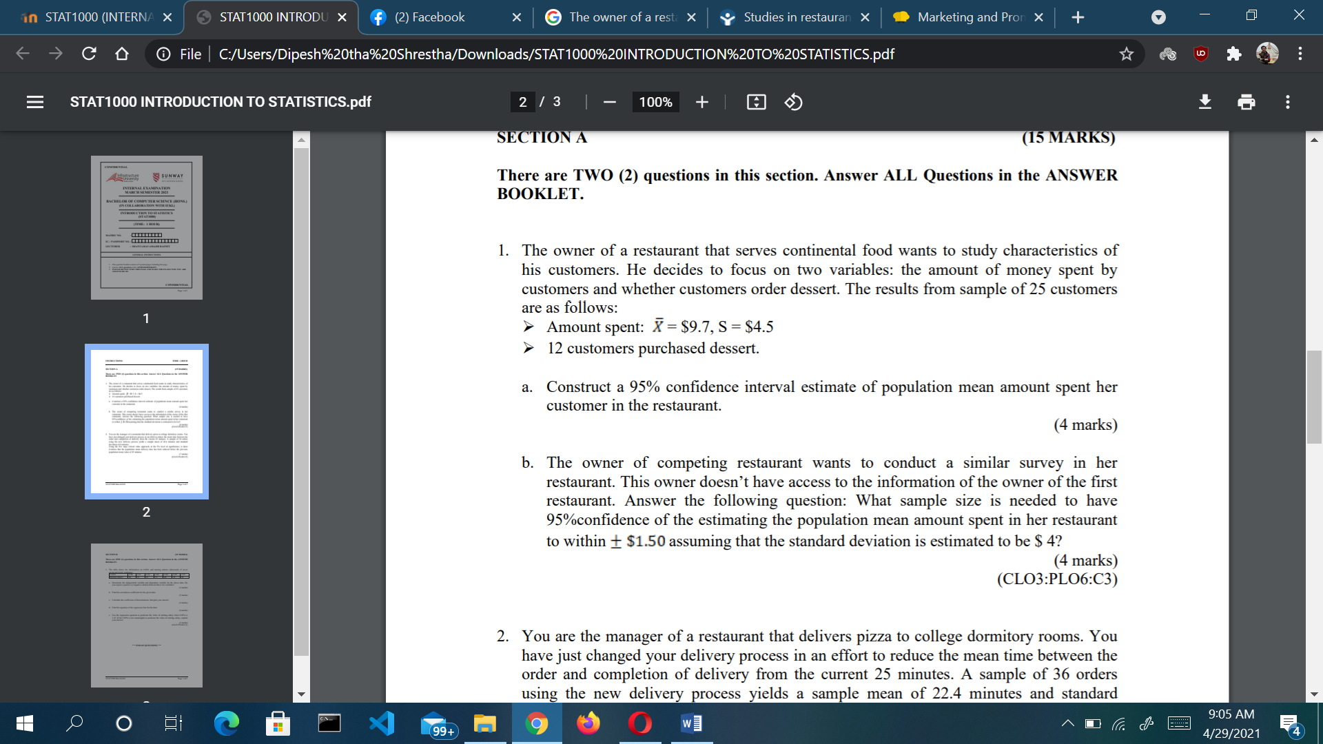

**Solution**

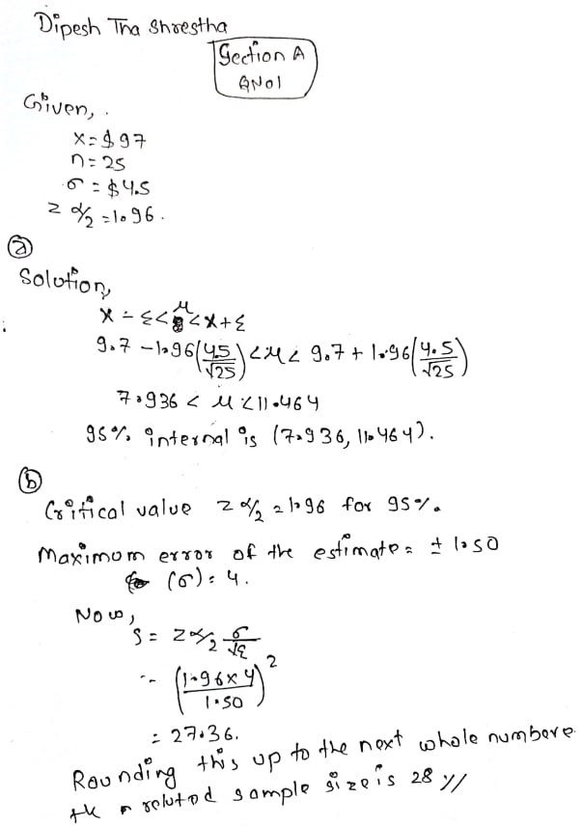

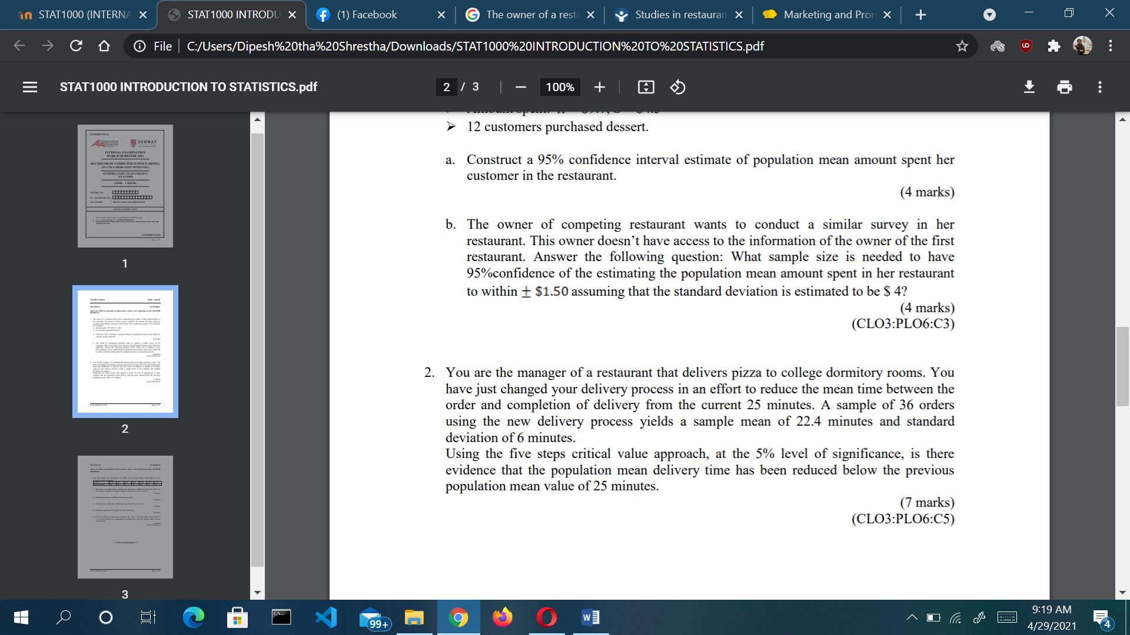

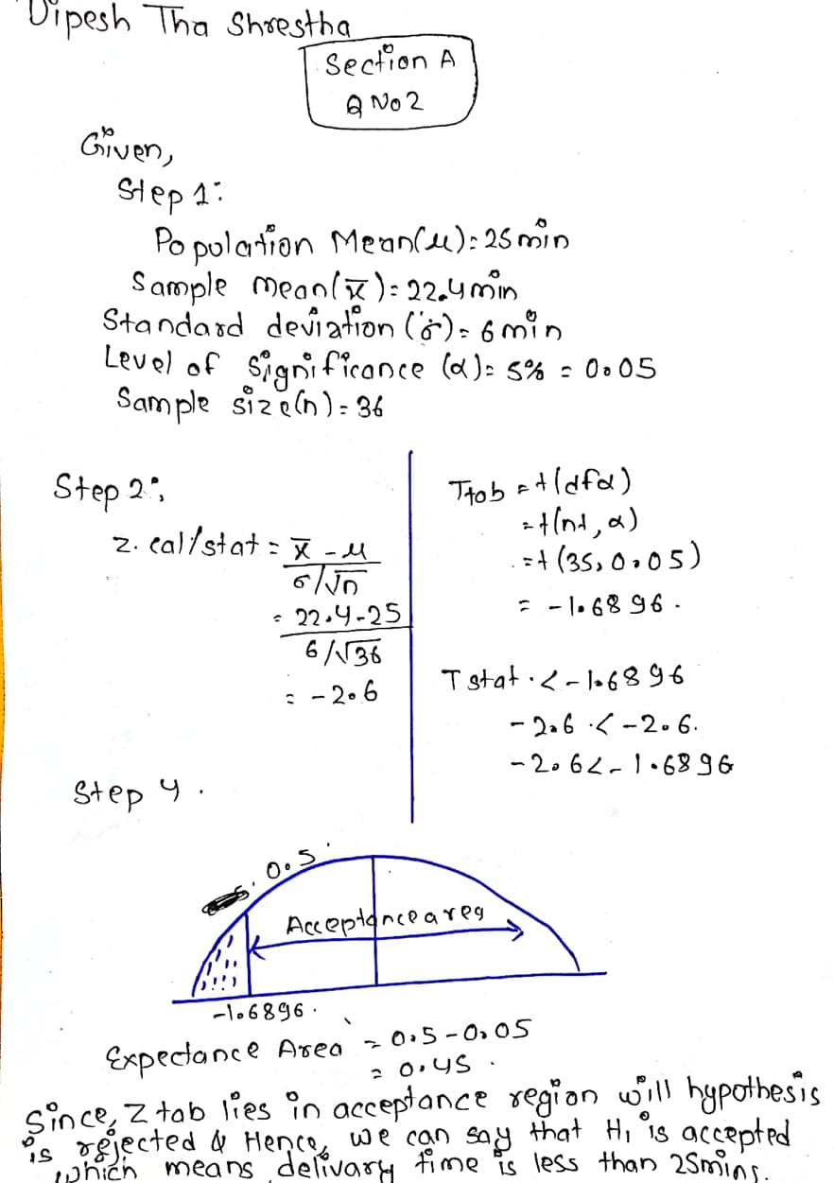

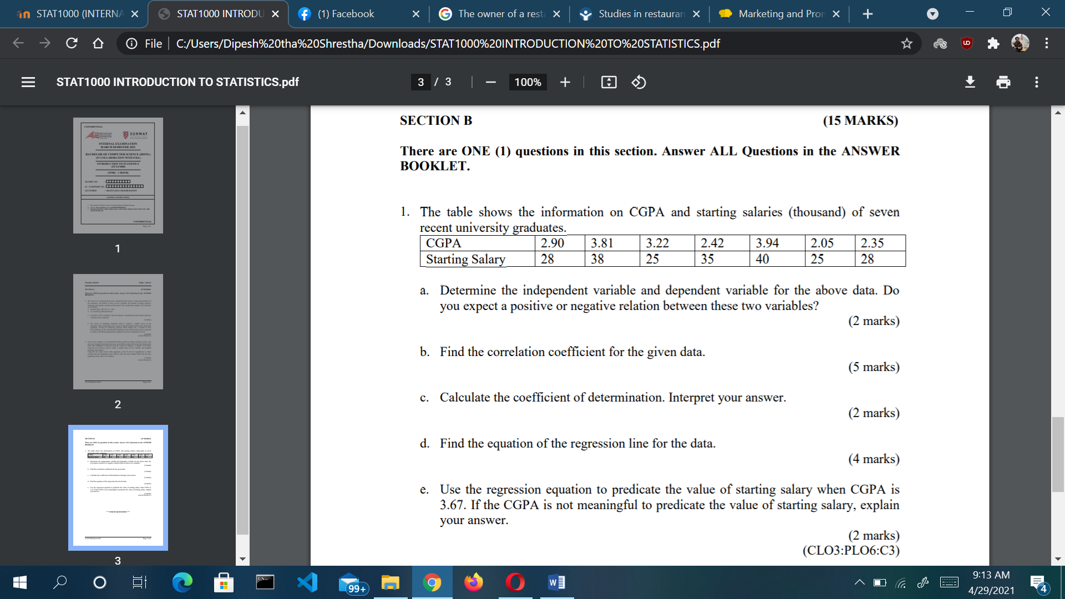

**Solution;**

